Predictive Modeling and Optimization in Logistics Systems

Objective
The objective of this project is to develop a predictive model to forecast delivery times in logistics operations and propose optimization strategies to improve efficiency, reduce operational costs, and enhance logistics performance.

Problem Definition
Logistics companies need accurate delivery time predictions for better planning and resource management. This project focuses on predicting delivery time using logistics-related variables such as shipment distance, shipment volume, and transportation cost.
Target Variable:
- Delivery_Time_hours
Input Features:
- Distance_km
- Shipment_Volume_tons
- Transportation_Cost

Dataset Description
A hypothetical logistics dataset containing 50 shipment records was generated using Python. The dataset was created for predictive modeling purposes.
Dataset Variables
Variable | Description
Distance_km | Shipment distance
Shipment_Volume_tons | Shipment volume
Transportation_Cost | Transportation cost
Delivery_Time_hours | Delivery time (Target Variable)

4. Model Selection
Selected Model: Linear Regression
Linear Regression was selected because it is a simple and effective machine learning algorithm for predicting continuous numerical values. It is easy to implement and interpret.

5. Python Code
import pandas as pd
import numpy as np

np.random.seed(42)

df = pd.DataFrame({
"Distance_km": np.random.randint(100,1000,50),
"Shipment_Volume_tons": np.random.randint(5,30,50),
"Transportation_Cost": np.random.randint(5000,40000,50),
"Delivery_Time_hours": np.random.randint(5,30,50)
})
Model Training
from sklearn.model_selection import train_test_split
from sklearn.linear_model import LinearRegression

X = df[["Distance_km","Shipment_Volume_tons","Transportation_Cost"]]
y = df["Delivery_Time_hours"]

X_train, X_test, y_train, y_test = train_test_split(
X, y, test_size=0.2, random_state=42
)

model = LinearRegression()
model.fit(X_train, y_train)
Prediction and Evaluation
predictions = model.predict(X_test)

Model Training and Testing
The dataset was divided into training and testing datasets using an 80:20 ratio. The Linear Regression model was trained using the training data and tested on unseen data.

Evaluation Metrics

Metric | Value
MAE | 7.23
RMSE | 8.38
R² Score | -0.67
Interpretation
The MAE value indicates that the average prediction error is approximately 7.23 hours. The RMSE value of 8.38 indicates the overall prediction error magnitude. The negative R² score suggests that the model performance is limited because the dataset was randomly generated and does not contain strong correlations among variables.

Visualization
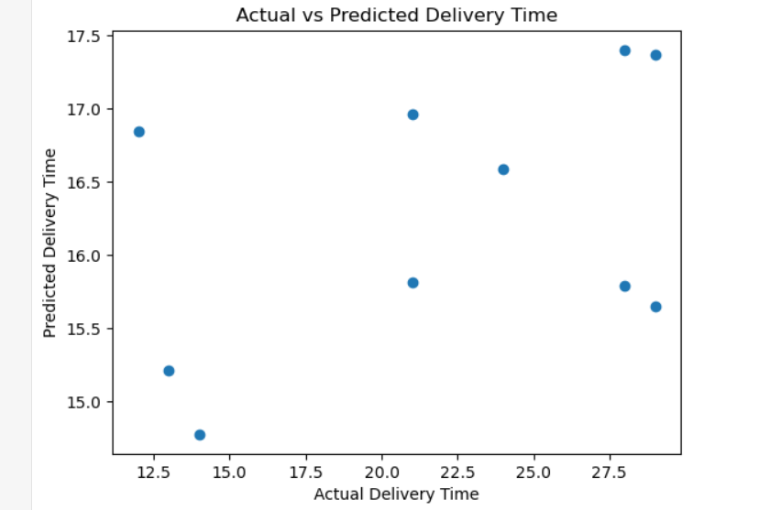
The visualization compares actual delivery times with predicted delivery times. It provides a visual assessment of model performance.
Optimization Strategies
- Route Optimization
Reduce travel distance and improve route planning.
- Resource Allocation
Allocate vehicles and manpower efficiently.
- Delivery Scheduling
Use predicted delivery times for planning deliveries.
- Cost Reduction
Monitor transportation costs and improve utilization.
- Performance Monitoring
Track logistics KPIs regularly.

10. Key Insights
- Delivery time prediction supports logistics planning.
- Predictive analytics improves operational efficiency.
- Transportation cost and shipment distance are important logistics variables.
- Data-driven decisions can reduce delays and improve service quality.

11. Recommendations
- Implement predictive models in logistics planning.
- Optimize routes to reduce costs.
- Monitor delivery performance continuously.
- Use machine learning for forecasting and scheduling.

12. Conclusion
This project demonstrated the application of predictive modeling in logistics using Python. A Linear Regression model was developed to forecast delivery times based on logistics variables. The model was evaluated using MAE, RMSE, and R² Score. Although the dataset was hypothetical, the project successfully illustrated how predictive analytics and optimization techniques can improve logistics planning, operational efficiency, and decision-making.

